Dr Thomas Proffen,  Chairman, Mantid Project Management Board  Neutron Sciences Directorate  Oak Ridge National Laboratory  Oak Ridge, TN  USA  25 April 2014 | Prof Robert McGreevy  Science and Technology Facilities Council  STFC Rutherford Appleton Laboratory,  Harwell Oxford,  Didcot, OX11 0QX United Kingdom  Tel +44 (0)1235 445000 Fax +44 (0)1235 445808 www.scitech.ac.uk  Director, ISIS  Direct line +44 (0)1235 445599  E-mail robert.mcgreevy@stfc.ac.uk

Dear Thomas,

In accordance with the recently agreed governance model for the Mantid project, I would hereby like to request that ISIS be approved to continue as a member of the project.

- We agree to the project membership terms as laid out in version V2.R4.M0 of 04-March-2014.

- Mantid will be the default data reduction framework for almost all ISIS instruments. Our roadmap for future development is as laid out at http://trac.mantidproject.org/mantid/roadmap .

- We have already invested over 50 person-years of effort into Mantid development since starting the project in 2007. We would expect to provide ongoing support at the level of 1 FTE per 2-4 instruments, with the current level being 1 FTE per 2.5 instruments. This would be as part of a move towards supporting scientific computing in general at an average level of 1 FTE per instrument.

With best regards,
Robert
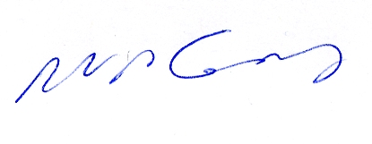
Prof Robert McGreevy
Director, ISIS

